**SAAN KA** Designing for documenting Manila’s Traffic Epidemic

Junwoo Cheong, Julie Choi, Ari Daly, Isadora Krsek, Robert Managad

**INTRODUCTION**

The commuting experience in Metro Manilla is facing growing animosity and dissatisfaction. As one of the, if not *the* densest, populations in the world, Manilla commuters are forced to travel in capacity-exceeded, dangerous modes of transportation such as trains, jeepneys, and buses. Social and economic class divisions further differentiate the leisurely traveling experiences of the elite (often policy-makers and government officials) from the suffocating commute experiences of the much more populated middle and lower classes. This has led to more and more voices entering the realm of social media to express more volatile concerns. However, with people posting on a variety of social media platforms, it becomes more and more difficult to attribute value to these scattered voices.

This was the opportunity space presented to us by Assistant Professor Noah Theriault in his presentation *Life in Waiting: A Digitally Enhanced Anthropology of Manila’s ‘Traffic Crisis’.* In response and under Noah’s supervision, we developed Saan Ka (*Where Are You?)*, a human-centered data collection experience that is aimed at helping researchers at Carnegie Mellon record and amplify the voices of under-recognized populations. Saan Ka crowdsources logistical and emotional data about the commute experiences of participants, then organizes information spatially for researchers to visually analyze and present. At the time of writing, Saan Ka exists in the Hi-Fi mobile prototype state, including an entirely fleshed-out data collection experience, an integrated visual design, and an anonymous social feature that encourages user sharing.

**PROJECT SCOPE AND DEVELOPMENT**

The scope of this project touches the lives of several groups of people, namely: Noah and the team that he accrews, the research participants, and policy makers. This app enables Noah and his team to conduct research through the compilation of information submitted to them by participants. In addition, the app user experience takes into consideration that the research participants come from diverse economic, social, and political backgrounds. Finally, we feel that if this work gains enough traction and attention from the participants, it could bring global or national social awareness to this issue and provide policy makers with a perspective that is all too often ignored by them.

In terms of developing the product, there were several points that we needed to anticipate and carefully consider because there existed potential unintended consequences and unpredicted user behaviors that could affect ideal data collection. One of these concerns involved the accessibility of this app for different types of users: compared to users who mainly use more public and crowded transportation methods, those who commute as passengers in cars are more likely to spend time on their phone during their commute. This could lead to a bias in data. Another risk touches on the matter of anonymity. Anonymity made the “social” aspect of our project harder -- we needed to make sure that the people using this platform felt minimal consequences from Saan Ka, if any at all. The potential for accidental documentation of illegal activity and stalking participants’ routes, for example, were early concerns of ours.

**PRIOR RESEARCH**

So as to inform our design, we drew upon knowledge from prior studies conducted by Noah, in addition to various articles documenting the traffic epidemic he sought to address in the first place. Noah graciously provided us with a great deal of articles so as to inform our understanding of his vision of the project from the perspective of designing digital media for para-ethnographical purposes. In all, because we had the most trouble tackling the idea of how to create a digital mobile space that facilitates and encourages one to document personal travel narratives, we focused our efforts in the Literature Review on articles and papers centered around digital storytelling; specifically digital storytelling in an ethnographical context.

The latter was extremely useful to us, particularly in the sense that there aren’t very many known apps which tackle transit documentation in the way which Noah had envisioned; in their paper for the *Journal of Political Ecology*, “*Wellwatch: Reflections on designing digital media for multi-sited para-ethnography”*,Sara Wylie and Len Albright document their experience in prototyping a web-tool created to “make a collaborative space for communities and academics to monitor, study, and respond more effectively to the shale gas industry “ (Wylie, Albright, 2014). The project itself noted a few things which would be of great importance to us as we moved forward with our project, firstly: efficiently moderating the collection of data, WellWatch in its nature was particularly easy to modify and spam which in turn brought the site down on various occasions, and which inevitably and irrevocably corrupted the database of information that they had collected. Any iterations or re-iterations would have revealed that and as such we were decidedly cautious with the refinement of our prototype. That being said it was particularly successful in its ability to allow communities to highlight and comment on the patterns they noticed in addition to allowing them the space to formulate their own opinions based on the aforementioned data. A few more important lessons that WellWatch imparted on us were the value of sharing collective knowledge amongst communities regarding specific problems and how that can inspire them to navigate or manage problems within their communities. This was a deciding factor in our decision to make the posts in Saan Ka visible to all contributors as well as researchers. Based off of this paper we came to the conclusion that feeding the information forward to volunteers would act as both an incentive for users and a way of showing them how the data is being used. We also felt that they would be able to use the data in ways that convenience them, for example if they recognized a terrible traffic jam in a specific location, they could then take an alternative route and hopefully save themselves time.

We drew upon various articles for inspiration with regards to designing the interface that volunteers would use in order to submit documentation in-app (looking back to *Uploading Selves: Intuit Digital Storytelling on YouTube*). As was cited in the conference paper *“Designing with Mobile Digital Storytelling in Rural Africa*,*”* authors Bidwell, Reitmer, Marsden, and Hansen wrote of designing an interface to support the creation of a digital narrative. They drew on the use of a photo carousel in order to enable a flexible ability to draw on visual cues on behalf of the user (or “storyteller” as they call it...). Allowing people to record certain information on a photo by photo basis supports the narrative that they are trying to build and is a feature we decided would be important to our app. We incorporated it in the form of encouraging users to tag specific photos with various emojis as a way of quickly documenting their emotional experience relative to that moment.

Also vastly important, which we gleaned from this article, is the idea of allowing our users to record their trip either iteratively or in one go; or some combination. Giving the users the capacity for refinement until their final story emerges helps to accommodate those documenting in different situations (i.e. in the middle of transportation, at home and after the fact, etc. ) and supports the unpredictable and hairied nature of travel in Manila. Finally, the third most influential piece of research from our Lit Review was Leon Cox and Mark Brough’s article for *The British Journal of Social Work.* In *“Digital Storytelling as a Social Work Tool: Learning from Ethnographic Research with Women from Refugee Backgrounds”*, the authors discuss the use of digital narratives as a catalyst for social work in addition to a source of information that can be used to address the various intricacies of counter-narratives in social practice related work. In our case, understanding the situation at stake for our user base (working-class citizens of Manila, who all too often go unacknowledged by political officials) it was essential to begin to have some foundation for understanding the ways that technology has been leveraged to empower its users, and furthermore how it can be used to trigger more comprehensive conversations revolving around the experiences of those aforementioned people.

**DESIGN PROCESS/METHOD**

Before starting off with any prototype, we initiated our ideas with post-its to ensure that we all had the same vision for this project. To organize the different ideas and constraints, we pasted the various features that we had in mind into two different categories: minimum viable product and reach goals. One of the noteworthy ideas that we came up with was an emotion map that showed the data entries of all users and their associated feelings, providing a platform to voice their frustrations. Through this process, we were able to pitch our own ideas for integrating social interactions into the app.

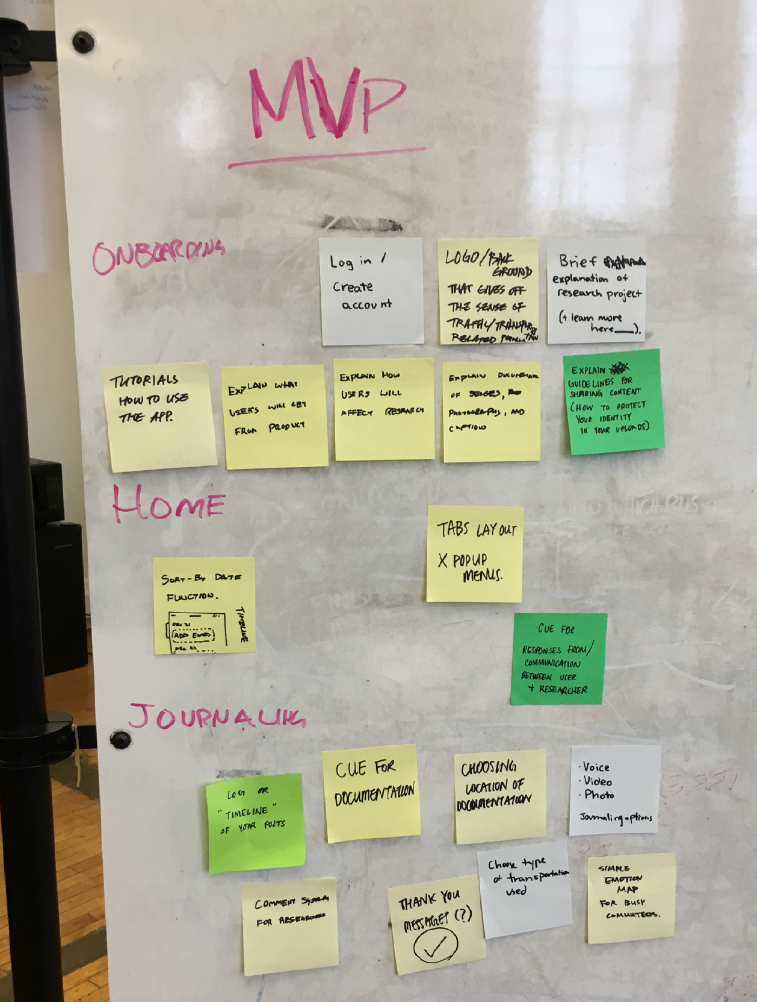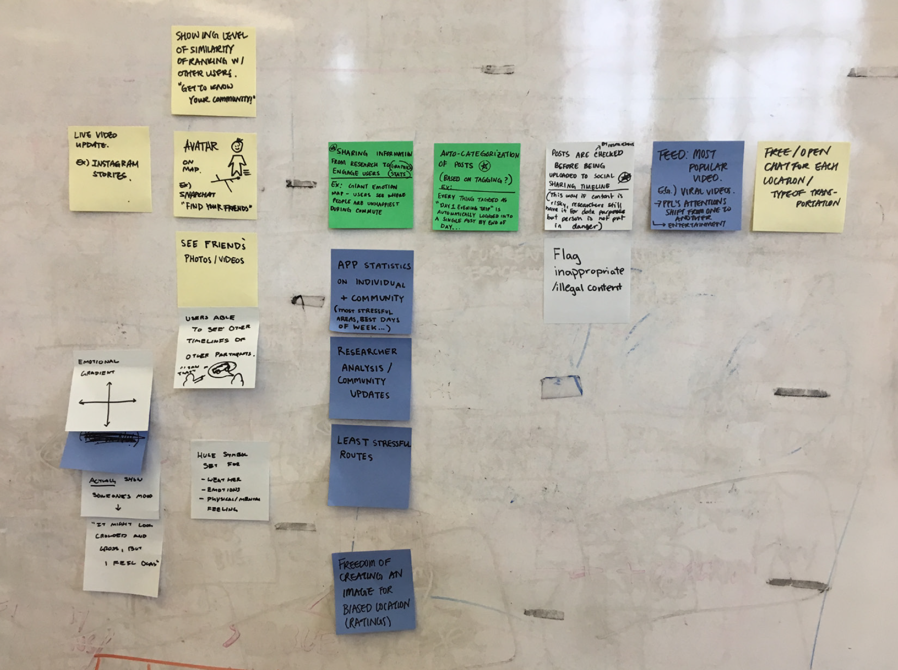

**PAPER PROTOTYPING**

Carrying out the vague direction we had, in order to determine the types of features to include, all five of us brought paper prototypes to share with one another. This was one of the crucial parts for us in terms of group work because we all had the same goal yet different perspectives on achieving it. When it came to choosing each feature as well as the flow between them, we discussed the pros and cons of each.

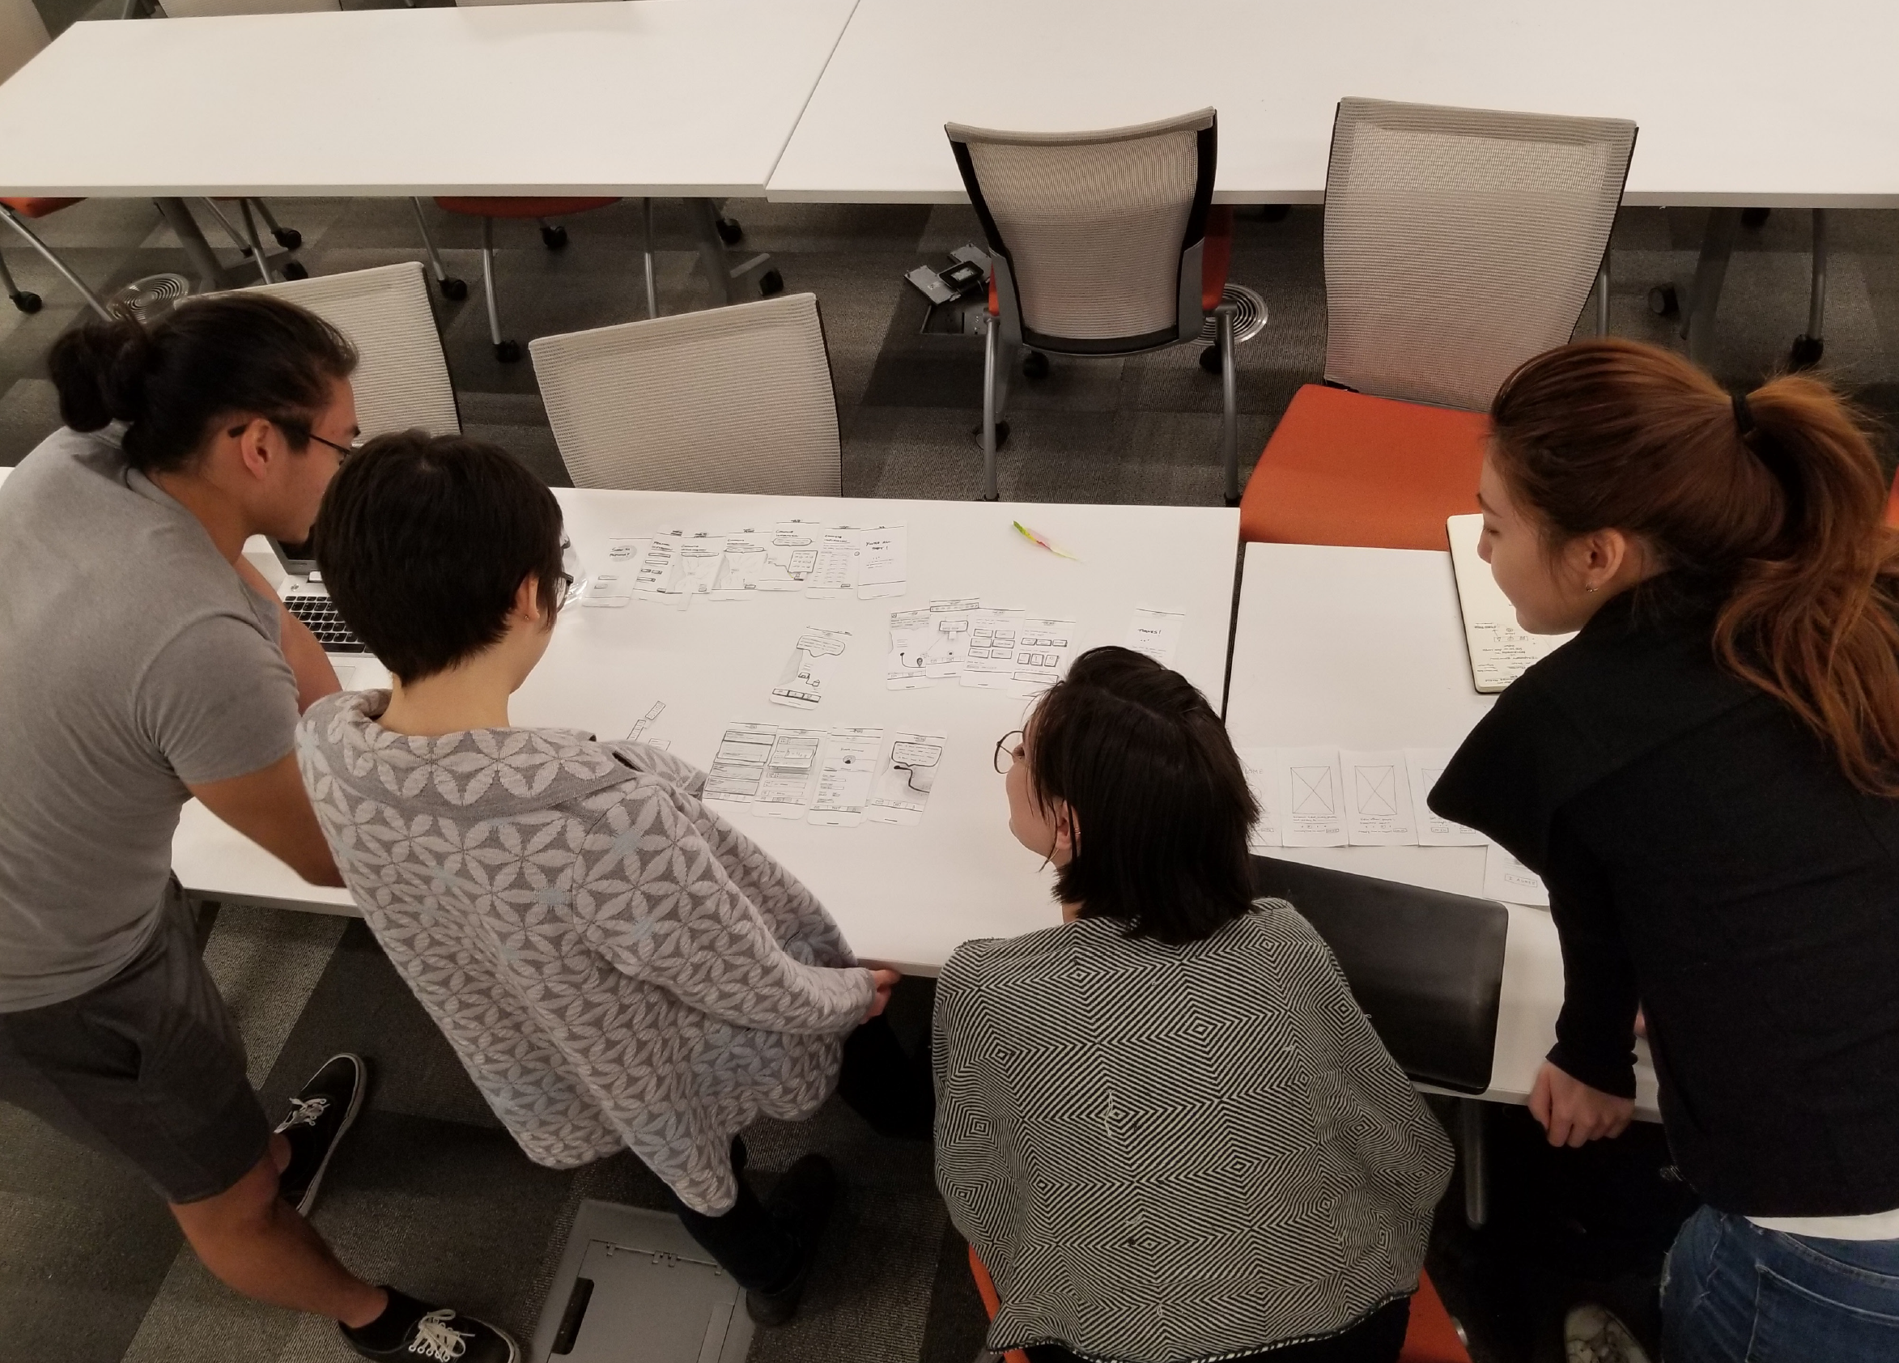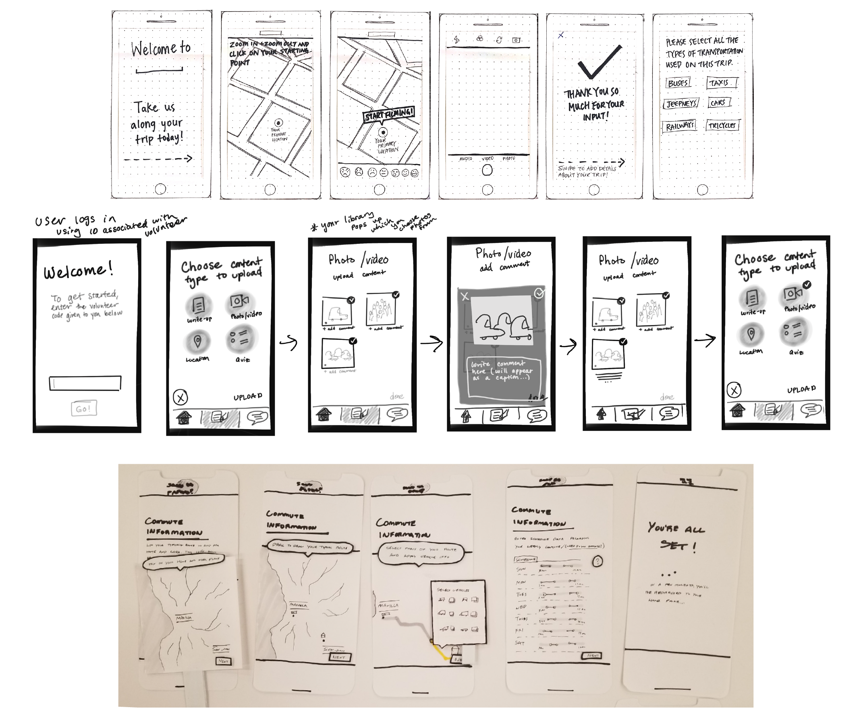

**USER FLOW**

After reviewing each of our paper prototypes, we started to sketch out the user flow on a whiteboard in order to nail down what the necessities and additional features are. This was a long process for us because we constantly switched out the different features and categorization of different pages of our application.

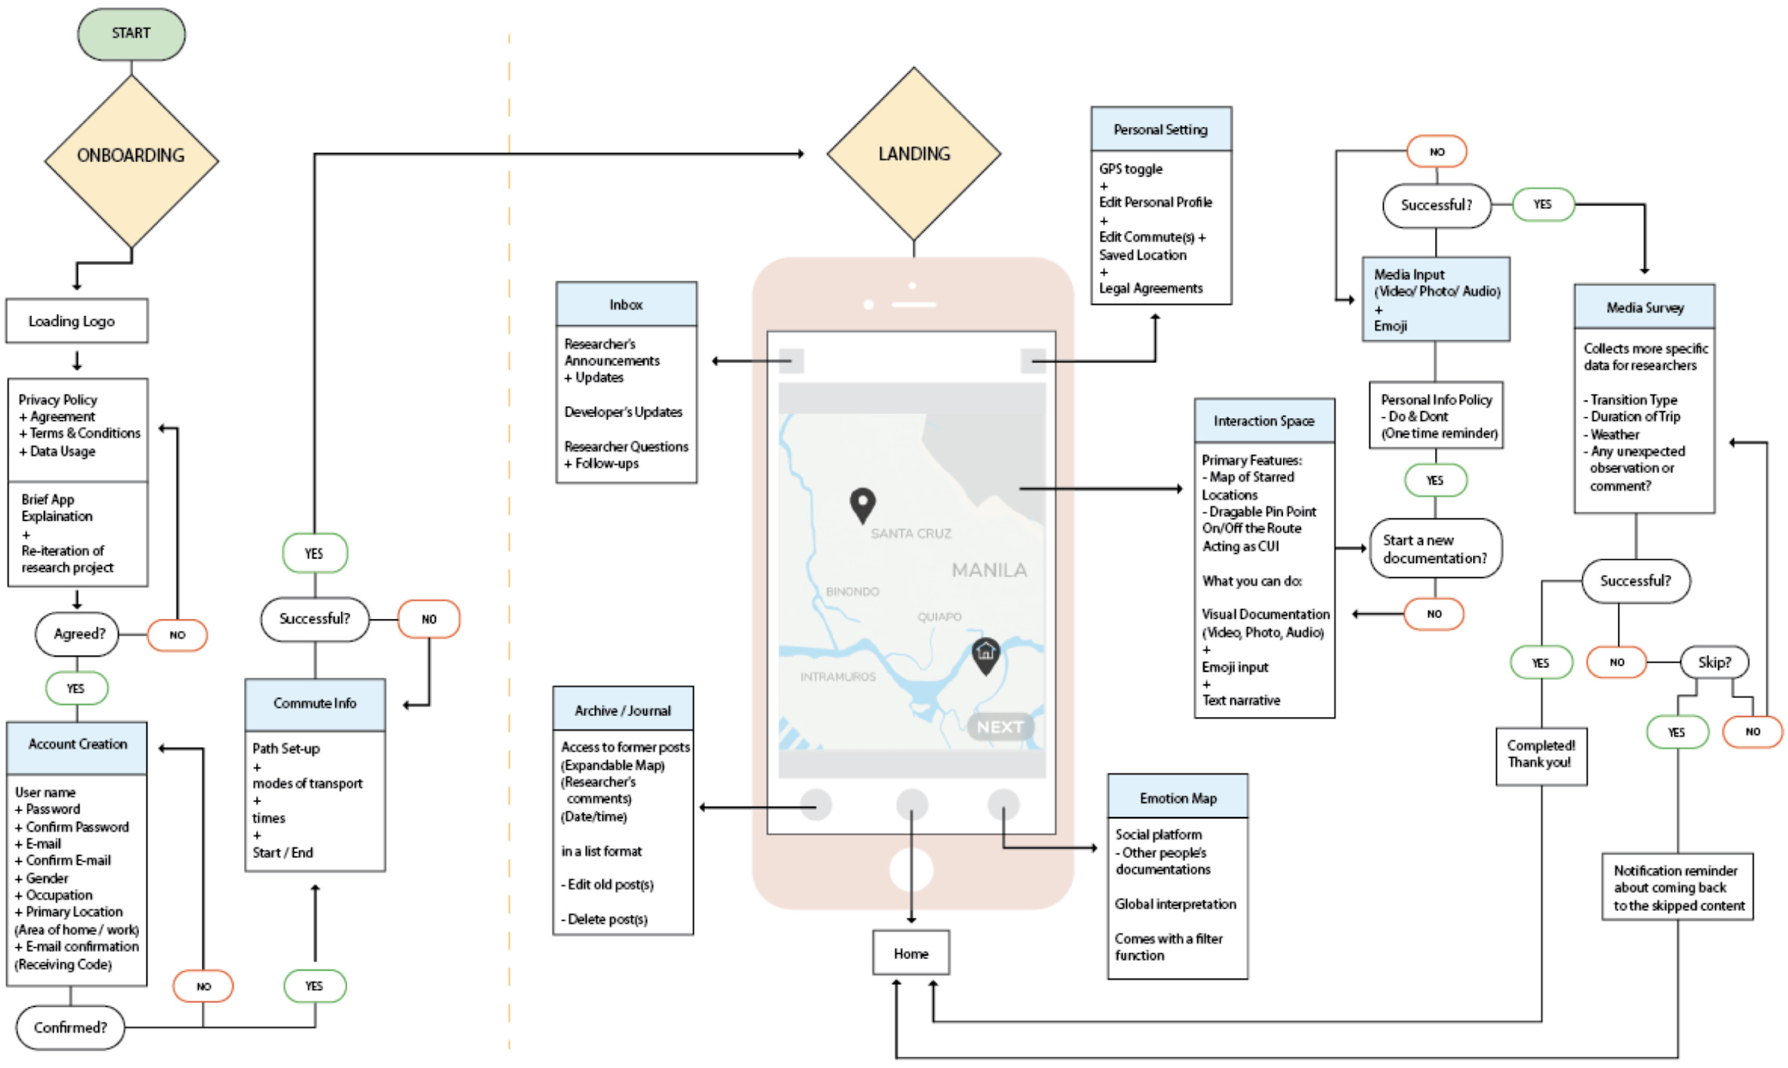

For the onboarding pages, we wanted to include instructions with a login and sign-up button. Moving on to the sign-up page, we spent a fair amount of time discussing the type of information that we would want from our users, while also not requiring too much personal information. Thus, we chose to input sections for the user’s username, password, e-mail, gender, occupation, and primary location. The user’s primary location (such as their home address) is essential information for Noah and acts as a grounding-reference point for users.

When it came to the home page, we debated whether the user should start from a map, or the archive containing a collection of past data submissions. We came to the conclusion that a map view would be most conducive in encouraging users to document their experiences.

Along with the home page, we included navigation for the archive, emotion map, inbox, and personal settings. The archive would specifically show former posts in a list view with the function to edit or delete at anytime. The emotion map was an extra feature from our post-it activity in which we give an overview of all the other user’s average emotions for every neighborhood in Manila. This feature was heavily discussed between us because didn’t directly inform the research aspect of the app. However, we made our final decision to include it as a feature for the longevity of the application; if we want the users to engage in with the app over in the long term, we need to provide information that is useful to their lives. As for the inbox feature, it is important that the researchers have the ability to contact users with any follow-up questions, announcements, or updates with regards to the application. In the settings tab, the user would have the freedom to toggle privacy settings, edit personal their profile, and review the terms & conditions of the app/research study.

**ITERATION 1**

After sketching the user flow, we started to flesh out the digital low-fidelity prototype on Figma. In the process of digital prototyping, we changed the locations for some of the features based on the phone dimensions and internal user testing.

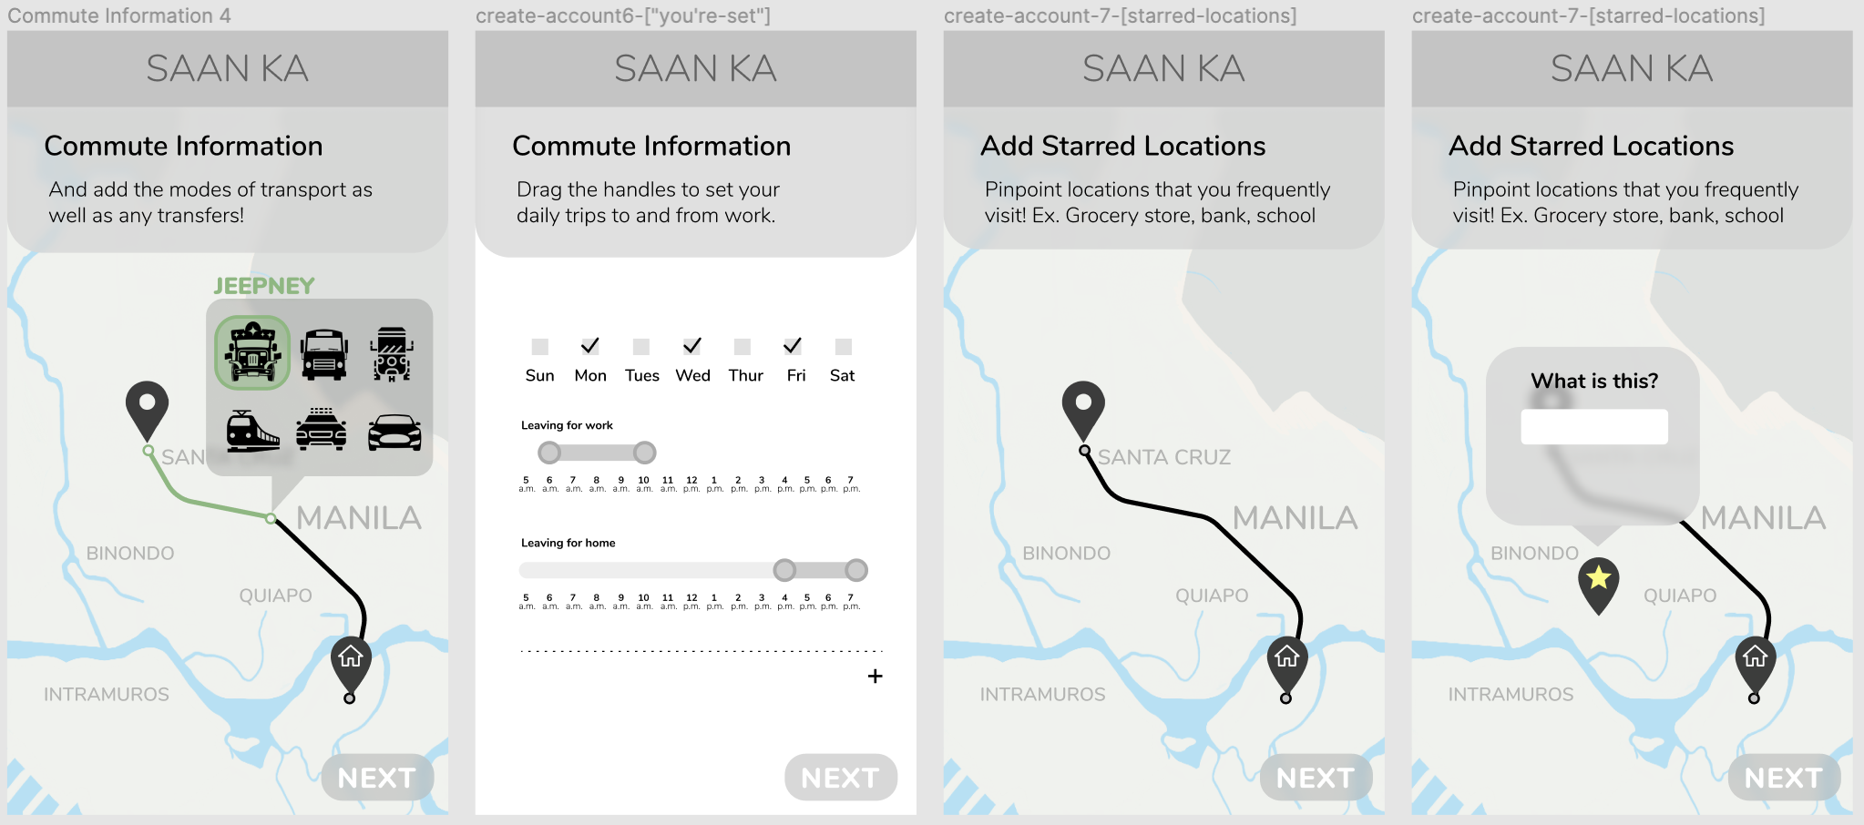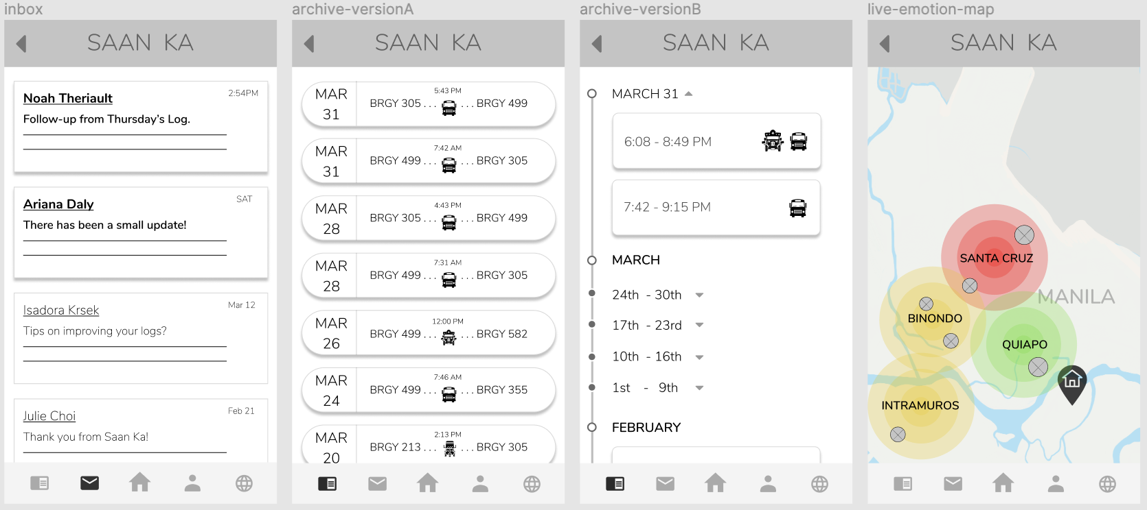

When we presented our first digital prototype with Noah, we received feedback that we need to work on some of the features in the application. Our onboarding process was far too long which also made the logging experience excessively tedious.

**ITERATION 2**

Keeping in mind Noah’s feedback, we made the onboarding process shorter, and revamped the logging experience for more ease of use.

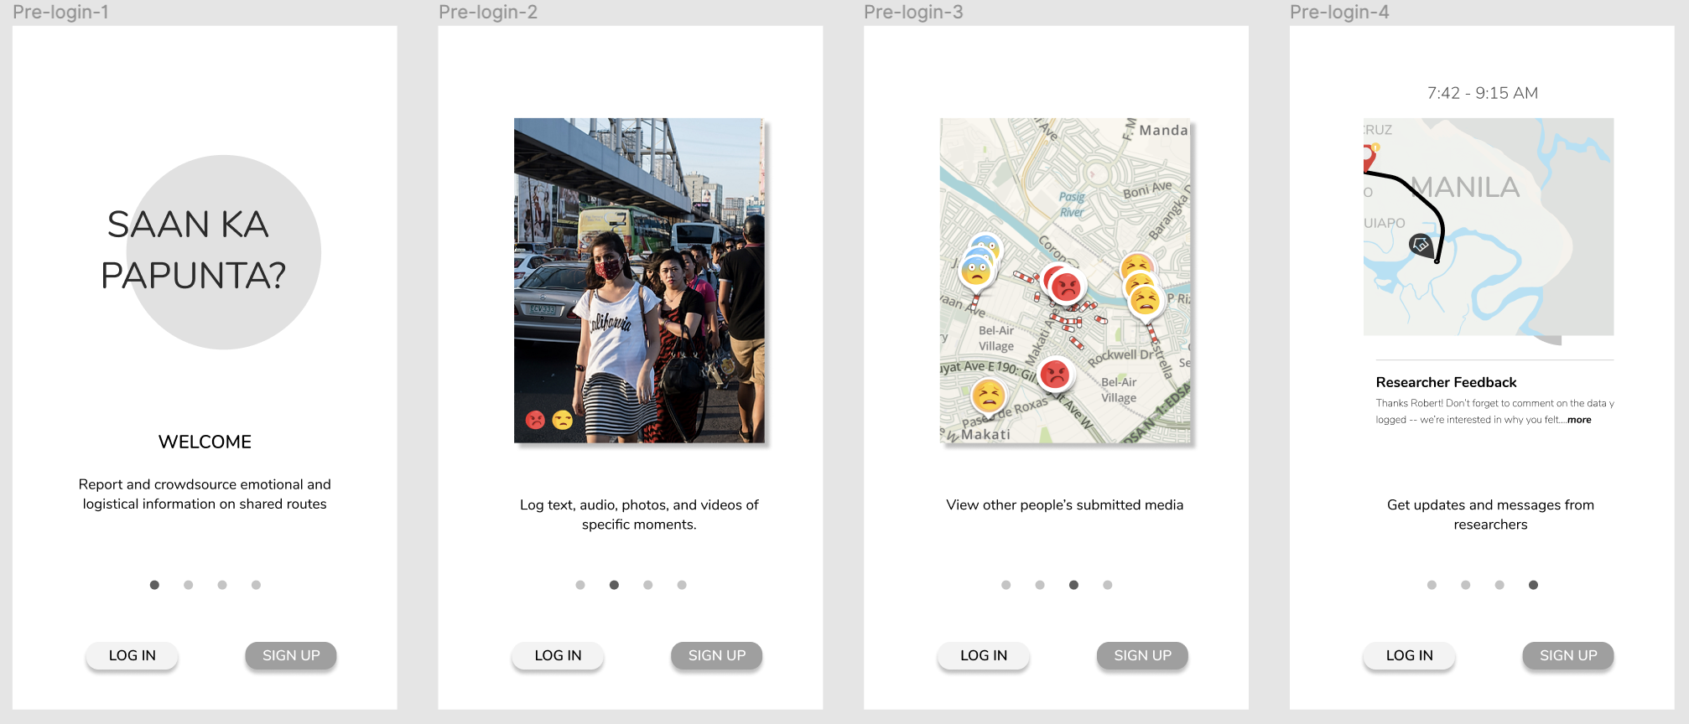

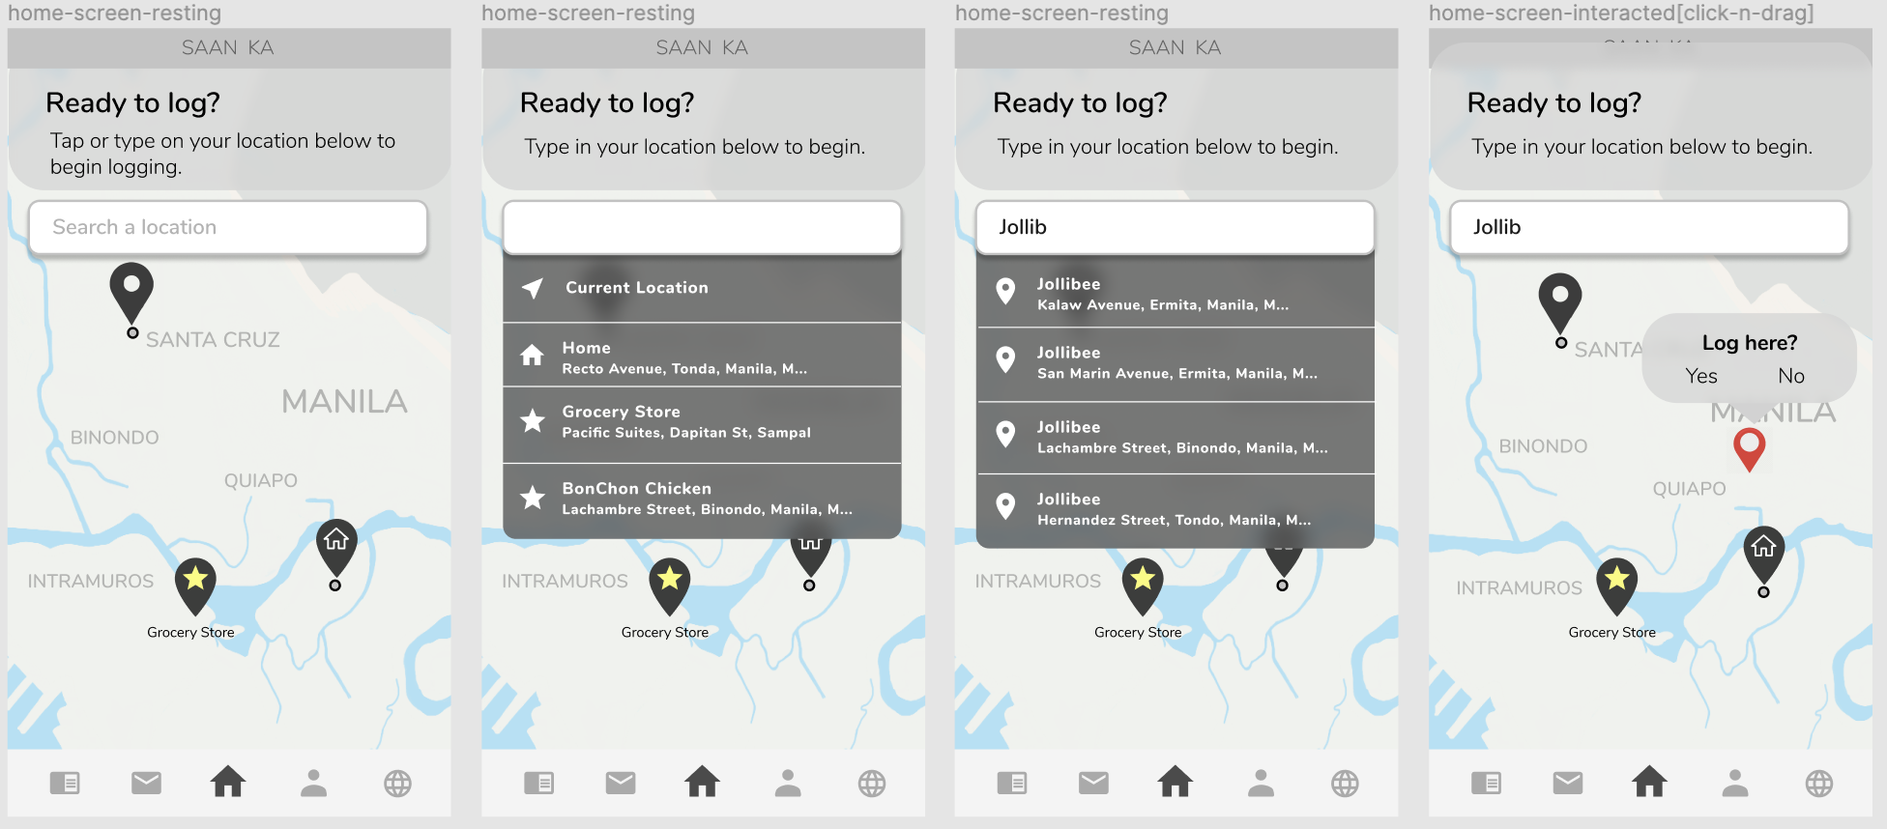

**USER TESTING IMPLICATIONS**

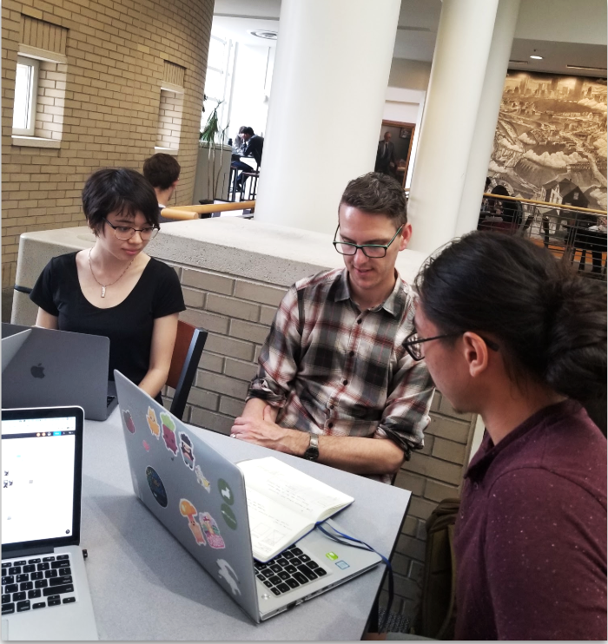

After internally testing our app as a group, we showed our prototype to our client, Noah Theriault. In this phase of our prototype, users were logging their route from start to end.

A route has:

1. Start location
2. Location of where the photos/videos were taken
3. End destination

The incorporation of both the start and end destinations in the submitted media would help link multiple photos taken while on the same route. Since our home page was the map, we decided to start with the route information.

The user flow was as follows:

1. Submit route data
   1. Start location
   2. Location of where the photos/videos were taken
   3. End destination
2. Add media
   1. Photos
   2. Videos
   3. Emojis
3. Complete survey
   1. Transportation used
   2. Weather
   3. Short answer questions

For this flow, Noah noted that users took multiple steps before reaching the camera to submit their media. Since users might want to use the in app camera, they might miss their shot if they have to take a minute to fill out the route data first. He also mentioned that users may not have access to data at all times. It’s relatively common to run out of data or save data by using their phone predominantly in the range of WiFi. This would then raise an issue in our user flow-- if users wanted to draft a submission and then complete the sections that required data/WiFi later, they could get stuck at the very beginning when wanting to search for locations.

In order to incorporate this feedback, we changed the user flow to as follows:

1. Location of where the photos/videos were taken
2. Add media
   1. Photos
   2. Videos
   3. Emojis
3. Complete survey
   1. Transportation used
   2. Weather
   3. Short answer questions
4. Submit route data
   1. Start location
   2. End destination

In this flow, we chose to keep the location of the media at the beginning because the user starts on the map, the location is necessary to contextualize the photos, and users could use their current GPS location (which does not require data). Our internal mental model of the routes and submission flow however did not translate to users.



When user testing, we realized that people didn’t understand the purpose of the app nor the flow of creating the research logs. Few people in our user testings read the onboarding text, and therefore didn’t have context for what the app was about. The issues in logging their experience started from the word “log”. Internally, we often referenced submitting photos/videos to researchers as “logging”. This word on its own wasn’t able to explain itself to our users, and they were subsequently confused about what they were submitting and the purpose behind it.

Then seeing a map and the search bar on the top, they assumed that this was an app similar to Google Maps, but perhaps with a crowdsourcing component. They were then even more confused when they had to submit location data again at the end.

After our user testing, we dramatically changed the user flow to the following:

1. Add media
   1. Add emojis
      1. Primary feeling
      2. Secondary feelings
2. Optional add-ons to the media
   1. Start / End Locations
   2. Weather
   3. Transportation
   4. Notes
   5. Trip Duration

In this scenario, users press a plus button to add their media, and are prompted to use their camera immediately. They additionally have the option to make either quick submissions or in depth ones. This streamlined flow makes the submission process easier to understand and accommodates the different scenarios and levels of motivations of the users.

In addition to the submission user flow, we also integrated the emotion map into the home screen, removed the commute route information from the onboarding, and added color into our next prototype.

**HI-FI PROTOTYPE**

Our research culminated in a dynamic and extensive high-fidelity prototype.

To give a walkthrough of the final product, from the homepage users can toggle between a view of just their own submissions or the anonymous submissions of all volunteers. They can also filter the data that they see through various categories, such as weather, time, date, mode of transportation, or weekday.

The process of documentation itself remains much the same wherein users start off with submitting mandatory photos and/or videos and then attaching emojis to them to replicate the emotions they experienced during this portion of their transit. Previous photos attached to this submission are shown below in a carousel format. From there they are brought to a screen which prompts them to submit at least two more forms of documentation of their choice (all of these extra forms of documentation appear in pop-up windows so as to not overload our users during the process of documentation). Following that step they are then asked to either confirm that the geotagging of their photographic information is correct (if they have GPS/Geotagging enabled) or they are asked to drag the photographic documentation to the right location on the map, so as to provide a more comprehensive narrative of information to researchers reviewing the information submitted to the application.

After the user finishes documenting and submits their information, they can then see the faint ghost of their logs on the homepage (which then disappear by the next day, giving users a clean slate to work with). They then can choose to submit more content, on their own or after being prompted by researchers with follow-up questions.

From the menu, the user can access the home-page, their inbox (for correspondence with researchers), a settings page (modify “starred”, or frequently visited, locations, account settings, and view the data usage policy), and an archive wherein the user can go back and modify posts that they may not have finished.

NEXT STEPS & CONCLUSION

The working mobile prototype was the top priority of the project, but we also recognized the need of UX/UI development for researcher’s end. From the post mid-review check up with Noah, we identified researcher’s need and decided to take initiatives on creating a desktop UI.

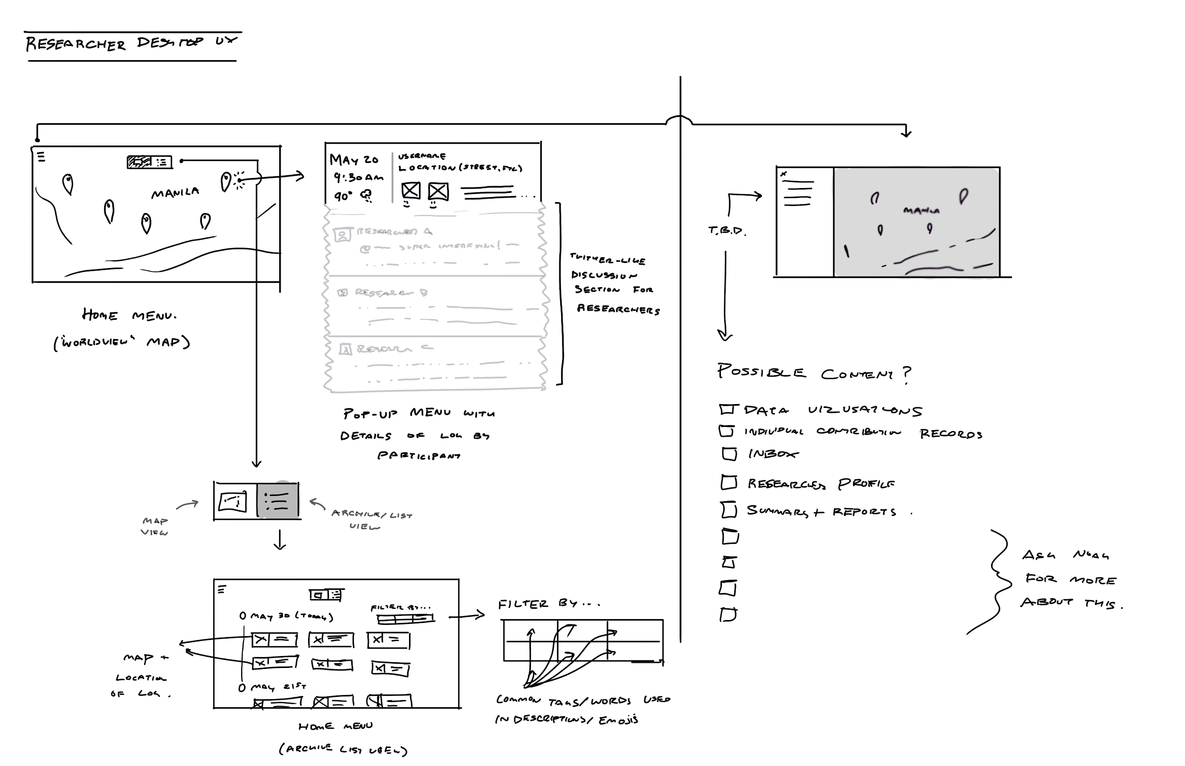

Note about desktop UI for researchers (from meeting with Noah)

We discussed ideas about what the desktop for Noah and co-researchers would need to look like and identified a few key features.

* Flexible organization of submitted logs to improve researcher’s interaction quality.
  + Logs accessible and filtered by
    - Date
    - Time
    - Location
    - Common tons
    - Emojis (emotion)
    - Words used in descriptions
  + Map view (the world view) & List view
* Landing area for external communication (with Saan Ka users) and internal communication ( with co-researchers and assistants)
* Other consideration points included:
  + Data visualization
  + Individual contribution records
  + Inbox

Unfortunately, our group wasn’t able to start prototyping the desktop UI. However, the desktop UI holds great potential to significantly improve the experience of the researchers.

**FUTURE SPECULATION**

*In 1 year*

Fully developed Saan Ka is launched and Noah uses it to conduct his research in Manila. Research participants use the app to log daily experience and find the app appealing.

Citizens create strong ties to Saan Ka as it becomes a platform for the voices of under-represented citizens in the midst of Manila’s horrendous traffic epidemic.

*In 5 years*

Saan Ka usage starts to grow and voices cluster to create bigger impact. Manila’s policy makers start to recognize the concerns of their constituents through the reach of Saan Ka.

Saan Ka grows beyond a data collection app, and becomes an influential social platform in Manila.

*In 10 years*

Saan Ka has significantly grown and empowered people’s voices; making complaints on issues about traffic and public transportation heard. Actual policies that reflect citizens’ opinions are being introduced in Manila. Saan Ka becomes a good alternative to Google Maps as users find emotional feedback additionally useful.

**References**

Bidwell J. Nicola & Reitmaier Thomas & Marsden Gary & Hansen Sarah, (2010).

Designing with Mobile Digital Storytelling in Rural Africa. Retrieved from: <https://www.researchgate.net/publication/221517446_Designing_with_mobile_digital_storytelling_in_rural_Africa>

Brough Mark & Cox Leonie, (2013).

# Digital Storytelling as a Social Work Tool: Learning from Ethnographic Research with Women from Refugee Backgrounds. Retrieved from: <https://academic.oup.com/bjsw/article-abstract/45/3/988/1667167?redirectedFrom=fulltext>

Coca Nithin. (2019, Jan. 8). World’s Most Congested City Finally Shifts Gears.

Retrieved from:

<https://www.ozy.com/fast-forward/worlds-most-congested-city-finally-shifts-gears/89573>

Gubrium Aline, (2009). Digital Storytelling as a Method for Engaged Scholarship in Anthropology. *Society for Applied Anthropology, Vol. 31*, 5-9.

Nuñez-Janes, M., Thornburg, A., Booker, A., Penier, I., Pack, S., & Leverton, A. (Eds.). (2017). *Deep Stories: Practicing, Teaching, and Learning Anthropology with Digital Storytelling*. Berlin/Boston: De Gruyter. Retrieved from: <http://www.jstor.org/stable/j.ctvbkjvdr>

Theriault Noah, (2018). Surviving Carmageddon in Manila.

Retrieved from: <http://edgeeffects.net/public-utility-vehicle/>

Truitt Allison, (2008). On the back of a motorbike: Middle‐class mobility in Ho Chi Minh City, Vietnam. Retrieved from:

<https://anthrosource.onlinelibrary.wiley.com/action/showCitFormats?doi=10.1111%2Fj.1548-1425.2008.00002.x>

Scobie Willow & Wachowich Nancy, (2011). Uploading selves: Inuit digital storytelling on YouTube. Retrieved from:

<https://www.erudit.org/en/journals/etudinuit/2010-v34-n2-etudinuit5000473/1003966ar/>

Wylie Sarah & Albright Len, (2014). WellWatch: reflections on designing digital media for multi-sited para-ethnography. *Journal of Political Ecology, Vol. 21*, 320-348.

Yazici Berna, (2013). Towards an Anthropology of Traffic: A Ride Through Class Hierarchies on Istanbul's Roadways. *Journal of Anthropology, Vol. 78*, 515-542.